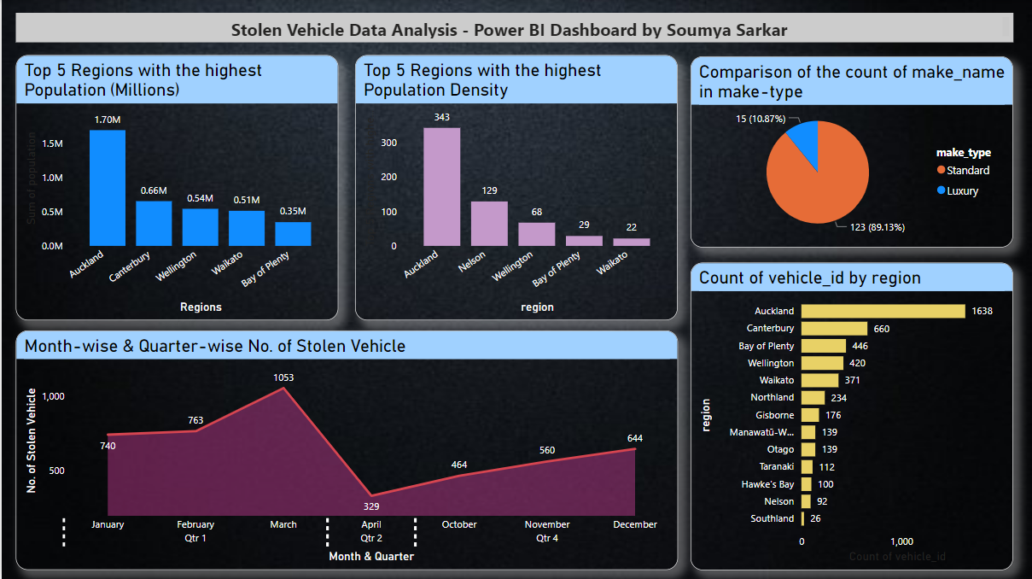

**Questions & Answers:-**

1. In your dashboard show the top 5 regions with the most population and the top 5 regions with the most population density.

**Answer:**

**Top 5 Regions with the highest population:**

Auckland

Canterbury

Wellington

Waikato

Bay of Plenty

**Top 5 Regions with the highest population density:**

Auckland

Nelson

Wellington

Bay of Plenty

Waikato

1. While make_type has more make_name and has less make_name

**Answer**:

**Standard** make_type has more make_name (123 or 89.13%)

**Luxury** make_type has less make_name (15 or 10.87%)

1. In which month did the maximum crime happen and in which quarter of the year?

**Answer**: In **March** and **Quarter 1,** most crimes happened

1. Try to find out location-wise, where most of the crimes have happened.

**Answer**: The most number of crimes happened in **Auckland**